**Ex.No:10A Date: 24/09/2024**

**Roll No:231901018**

**Ping to test the server connectivity.**

**Installing Python Ping**

pip install pythonping in windows python get-pythonping.py [in run command prompt]

**Python Ping (pythonping) is a public repository you can find on PyPI.**

from pythonping import ping ping('8.8.8.8') simply ping Google. you won’t see anything in your console if you just run this script. This is because our ping is **silent by default**, and does not print anything to screen.

If we want to see everything on-screen, we can simply use the verbose flag.

ping('8.8.8.8', verbose=**True**)

**Ping to test server connectivity**

**How to ping a website in python**

from os import system print('1. Ping Google') print('2. Ping Yahoo') print('3. Ping custom URL') while True:

key = int(input('Input your choice: ')) if key == 1:

system("ping www.google.com") elif key == 2:

system("ping www.yahoo.com") elif key == 3:

url = input('Enter URL: ') system("ping " + url) else:

print("Invalid Option!")

------------------------------------------------------------------------------------------------------------------------- import os

os.system("ping google.com") import os

os.system('ping 127.0.0.1')

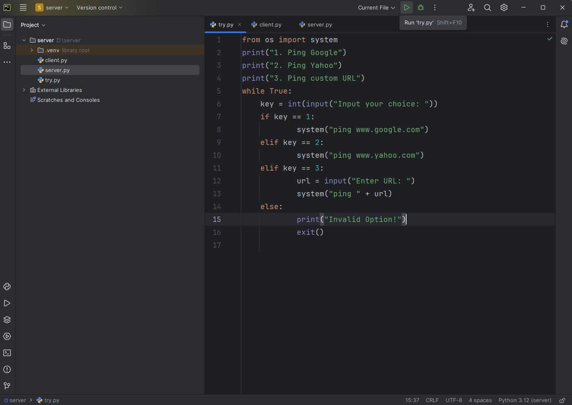

**Result:**

Thus, the server connectivity experiment using ping was done.